
Artificial intelligence
(LAB)


Submitted By:
Name: Maira
Roll No: 249
Section: BSAI-3D

Submitted To:
Sir Rasikh

Lab 4: Informed Search – Heuristics & A
Introduction:
In this lab, I studied how informed search uses heuristic values to find a suitable path between two locations. I used A* search on a campus navigation graph and compared its results with Uniform Cost Search (UCS).
The main purpose was to understand how actual path cost, estimated remaining cost and their combined value help a search algorithm choose the next node.
Problem Description:
A campus navigation system needs to find a low-cost route from building S to building G. Each edge represents travel-time cost, while heuristic values estimate the remaining travel time to the destination.
The graph contains five nodes: S, A, B, C and G.

Given Graph Information:

Starting Node | Next Node | Travel Cost
S | A | 1
S | B | 4
A | C | 2
B | G | 5
C | G | 3

Heuristic Values:
Node | Heuristic h(n)
S | 5
A | 4
B | 4
C | 2
G | 0

The starting node is S, and the goal node is G.
Important Concepts
1. g(n) – Actual Path Cost
It represents the total cost from the starting node to the current node.
2. h(n) – Heuristic Cost
It estimates the remaining cost from the current node to the goal.
3. f(n) – Evaluation Function
A* uses the following formula:
f(n) = g(n) + h(n)
The node with the lowest f-value is selected first.
4. A Search*
A* combines actual path cost and estimated remaining cost to find a low-cost route.
5. Uniform Cost Search (UCS)
UCS selects the node with the lowest actual path cost. It is equivalent to A* when all heuristic values are zero.
===================================================================

Task 1: Manual Calculation of g, h and f Values

Objective:
The objective of this task is to calculate g, h and f values manually for the first three expansions of A*. I also recorded the remaining frontier nodes after each expansion.
Formula:
f(n) = g(n) + h(n)
Initial Step:
The search starts from node S.
- g(S) = 0
- h(S) = 5
- f(S) = 0 + 5 = 5
Therefore, S is selected first.
First Expansion: Node S
Node S has two successors: A and B.
For node A:
- g(A) = 0 + 1 = 1
- h(A) = 4
- f(A) = 1 + 4 = 5
For node B:
- g(B) = 0 + 4 = 4
- h(B) = 4
- f(B) = 4 + 4 = 8

Frontier after expanding S:
Node | g(n) | h(n) | f(n)
A | 1 | 4 | 5
B | 4 | 4 | 8

Next selection: Node A is selected because its f-value is 5, which is lower than B's value of 8.
Second Expansion: Node A
Node A has one successor: C.
For node C:
- g(C) = 1 + 2 = 3
- h(C) = 2
- f(C) = 3 + 2 = 5
Node B remains in the frontier.
Frontier after expanding A:
Node | g(n) | h(n) | f(n)
C | 3 | 2 | 5
B | 4 | 4 | 8

Next selection: Node C is selected because its f-value is 5, which is lower than B's value of 8.
Third Expansion: Node C
Node C has one successor: G.
For node G:
- g(G) = 3 + 3 = 6
- h(G) = 0
- f(G) = 6 + 0 = 6
Node B remains in the frontier.
Frontier after expanding C:
Node | g(n) | h(n) | f(n)
G | 6 | 0 | 6
B | 4 | 4 | 8

Next selection: Node G is selected because its f-value is 6, which is lower than B's value of 8. Since G is the goal, the search stops.

Summary of First Three Expansions
Expansion | Selected Node | g(n) | h(n) | f(n)
1 | S | 0 | 5 | 5
2 | A | 1 | 4 | 5
3 | C | 3 | 2 | 5

Conclusion
A* selected S, A and C because they had the lowest available f-values at each step. After expanding C, the goal node G had the lowest f-value, so it was selected next. This shows how A* uses both actual and estimated costs to guide its search.

Output:
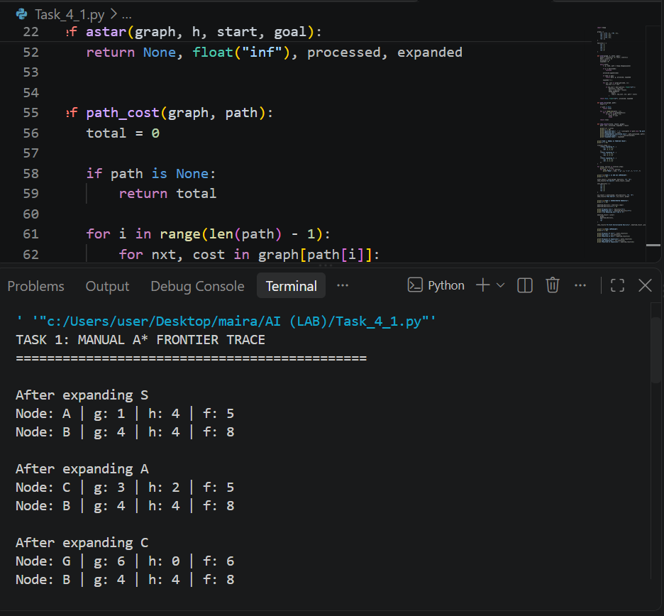
=====================================================================
Task 2: Comparison of A* and Uniform Cost Search (UCS)

Objective
The objective of this task is to compare A* and UCS using the same graph, starting node and goal node. I compared their returned paths, total costs and expanded nodes.
A* Search Results
A* uses the supplied heuristic values to select the next node.
Processed-node trace:
S → A → C → G
Returned path:
S → A → C → G
Path cost calculation:
1 + 2 + 3 = 6
- Returned path cost: 6
- Independently calculated cost: 6
- Expanded nodes: S, A, C
- Total expanded nodes: 3
The goal node G is processed to finish the search but is not counted as an expanded node because its successors are not examined.

UCS Results
For UCS, all heuristic values are set to zero:
h(S) = h(A) = h(B) = h(C) = h(G) = 0
UCS therefore selects nodes using actual path cost only.
Processed-node trace:
S → A → C → B → G
Returned path:
S → A → C → G
Path cost calculation:
1 + 2 + 3 = 6
- Returned path cost: 6
- Independently calculated cost: 6
- Expanded nodes: S, A, C, B
- Total expanded nodes: 4
The goal node G is processed but not counted as expanded.
Comparison | A* Search | UCS
Heuristic | Supplied values | All zero
Starting Node | S | S
Goal Node | G | G
Returned Path | S → A → C → G | S → A → C → G
Path Cost | 6 | 6
Processed Nodes | S, A, C, G | S, A, C, B, G
Expanded Nodes | 3 | 4
Expansion Count | 3 | 4
Comparison Table

Interpretation of Results
Both algorithms found the same lowest-cost path with a total cost of 6. However, A* expanded three nodes, while UCS expanded four nodes.
A* expanded fewer nodes because its heuristic values helped guide the search towards the goal. UCS had no heuristic information, so it also expanded node B before reaching the goal.
Stale Queue Entries and Goal Counting
In UCS, a higher-cost entry for G can remain in the priority queue after a cheaper route to G has already been found. Such an entry is called a stale entry and should be ignored if it no longer represents the best known cost.
The goal node is counted as processed when it is selected, but it is not counted as expanded because its successors are not examined. The same counting rule is used for both algorithms.

Conclusion
A* and UCS both found the optimal path in this experiment. A* expanded fewer nodes because it used heuristic information. This shows that a useful heuristic can improve search efficiency while keeping the same path cost.

Output:
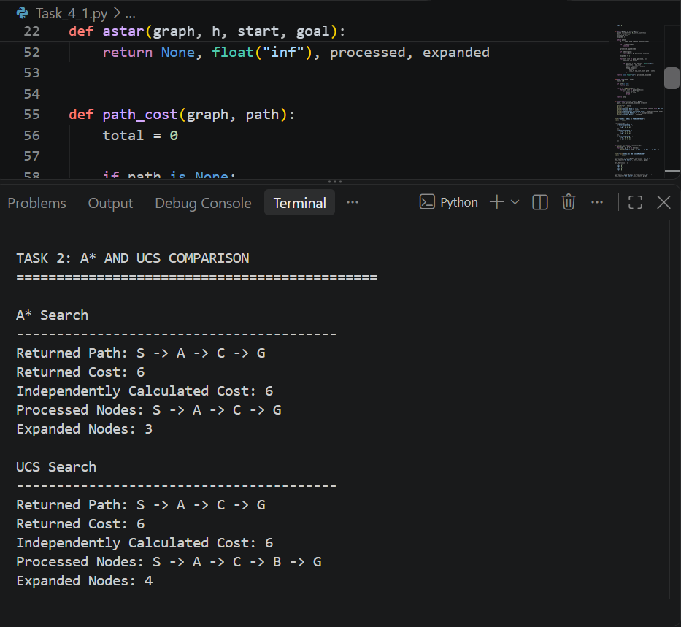
====================================================================
Task 3: Overestimating Heuristic and Failure Investigation

Objective
The objective of this task is to check how an overestimated heuristic value can affect A* search. I changed only the heuristic value of node C and compared the new result with the original result.
Original Heuristic Values
Node | Original h(n)
S | 5
A | 4
B | 4
C | 2
G | 0
Modified Heuristic Value
I changed only the heuristic value of C.
- Original h(C) = 2
- Modified h(C) = 10
- True remaining cost from C to G = 3
The new value of 10 is an overestimate because it is greater than the actual remaining cost of 3.
All other heuristic values and graph costs remain unchanged.
Effect on A* Search
After expanding S:
Node | g(n) | h(n) | f(n)
A | 1 | 4 | 5
B | 4 | 4 | 8
Node A is selected first because it has the lowest f-value.
After expanding A:
Node | g(n) | h(n) | f(n)
C | 3 | 10 | 13
B | 4 | 4 | 8
Now B is selected because its f-value is lower than C's value.
After expanding B:
Node | g(n) | h(n) | f(n)
G | 9 | 0 | 9
C | 3 | 10 | 13
Node G is selected next because its f-value is lower than C's value. The search reaches the goal through B.
Modified Search Results
Processed-node trace:
S → A → B → G
Returned path:
S → B → G
Path cost calculation:
4 + 5 = 9
- Returned path cost: 9
- Expanded nodes: S, A, B
- Total expanded nodes: 3
Original and Modified Results
Detail | Original Heuristic | Modified Heuristic
h(C) | 2 | 10
True Remaining Cost from C | 3 | 3
Returned Path | S → A → C → G | S → B → G
Path Cost | 6 | 9
Processed Nodes | S, A, C, G | S, A, B, G
Expanded Nodes | 3 | 3

Why Did the Result Change?
In the original experiment, node C had a low heuristic value, so A* selected it before B. This allowed the algorithm to find the path with a cost of 6.
After increasing h(C) to 10, the algorithm considered C less promising and selected B instead. It reached G through B with a cost of 9, even though a cheaper path with a cost of 6 existed.
This shows that an overestimated heuristic can cause A* to return a non-optimal path.

Conclusion:
The experiment shows that heuristic quality matters. An admissible heuristic does not overestimate the actual remaining cost. If the heuristic overestimates, A* can lose its optimality guarantee. However, not every overestimate will necessarily change the result in every graph.

Heuristic Audit
Objective
A heuristic audit checks whether the supplied heuristic values are suitable for A* search.
Admissibility Check
A heuristic is admissible if it never estimates a remaining cost higher than the actual cheapest remaining cost.
Node | True Remaining Cost | Supplied h(n) | Admissible?
S | 6 | 5 | Yes
A | 5 | 4 | Yes
B | 5 | 4 | Yes
C | 3 | 2 | Yes
G | 0 | 0 | Yes
All supplied heuristic values are equal to or lower than the true remaining costs. Therefore, the heuristic is admissible for this graph.
Consistency Check
A heuristic is consistent if:
h(u) ≤ cost(u,v) + h(v)
Each directed edge is checked below.
Edge | Calculation | Result
S → A | 5 ≤ 1 + 4 | True
S → B | 5 ≤ 4 + 4 | True
A → C | 4 ≤ 2 + 2 | True
B → G | 4 ≤ 5 + 0 | True
C → G | 2 ≤ 3 + 0 | True
The supplied heuristic passes all edge checks. Therefore, it is consistent on this graph.
Audit Conclusion
The original heuristic is both admissible and consistent for the supplied graph. The modified heuristic with h(C) = 10 is not admissible because it overestimates the true remaining cost from C.
=====================================================================
Failure and Edge-Case Analysis

Case: Overestimated Heuristic
Input: The heuristic value of C was changed from 2 to 10, while all other values remained the same.
Observed Behaviour: A* returned the path S → B → G with a cost of 9 instead of the optimal path S → A → C → G with a cost of 6.
Likely Cause: The increased heuristic value made node C appear less promising. As a result, A* selected node B and reached the goal through a more expensive route.
Proposed Improvement: Use a heuristic that does not overestimate the actual remaining cost. Check heuristic values against known shortest-path costs before relying on them.
Other Important Edge Cases
- If h(n) = 0 for every node, A* behaves like UCS.
- If the goal is unreachable, the search should report that no path exists.
- If a better path to an already discovered node is found, its best-known cost should be updated.
- Stale priority-queue entries should be ignored.

Limitations
- The graph is small and contains only five nodes, so the results may differ on larger maps.
- The edge costs are abstract travel-time units, not actual campus measurements.
- The heuristic values are supplied estimates and may not represent real distances.
- The search result depends on the quality of the heuristic.
- A* may use more memory on larger graphs because it stores frontier nodes.

Reflection
1. What did you learn today?
I learned how A* uses g(n), h(n) and f(n) to select the next node. I also understood how heuristic values affect the search result.
2. How will you apply this in a real AI system?
A* can be used in campus navigation, maps, games and robot pathfinding to find suitable routes between locations.
3. What failed or surprised you?
I was surprised that changing only one heuristic value could make A* select a more expensive route.
4. What would you do differently next time?
I would check heuristic values before running the algorithm and test different cases to make sure the results are reliable.

Responsible Practice
In a real navigation system, incorrect route estimates can lead to unreliable travel suggestions. Therefore, heuristic values should be based on reasonable and verified estimates.
The system should use accurate travel costs, handle situations where no route exists and clearly communicate that estimated travel times may differ from actual conditions.
I would also test the system on different routes before using it for real navigation.

Overall Conclusion
In this lab, I applied A* search to a campus navigation problem and compared it with UCS. Both algorithms found the same optimal path with a cost of 6 when the supplied heuristic was used.
A* expanded three nodes, while UCS expanded four. The overestimate experiment showed that changing one heuristic value could lead A* to a more expensive path.
Overall, I learned that a good heuristic helps improve search efficiency, while admissibility and consistency are important when discussing optimality.

References
- Artificial Intelligence Lab Manual, Lab 4: Informed Search – Heuristics & A*, Pages 16–18.
- Python Documentation, heapq — Heap queue algorithm: https://docs.python.org/3/library/heapq.html

Output:



